**Http Headers and Cookies**

**Http Header:** **HTTP headers** let the client and the server pass additional information with an HTTP request or response. An HTTP header consists of its case-insensitive name followed by a colon **(:)**

Headers can be grouped according to their contexts:

* **Request Headers:** contain more information about the resource to be fetched, or about the client requesting the resource.
* **Response Headers:** hold additional information about the response, like its location or about the server providing it.
* **Representation Headers:** contain information about the body of the resource, like it [MIME type](https://developer.mozilla.org/en-US/docs/Web/HTTP/Basics_of_HTTP/MIME_types), or encoding/compression applied.
* **Payload Headers:** contain representation-independent information about payload data, including content length and the encoding used for transport.

Listed Header Data that I found on <https://wasalt.com/en> are:

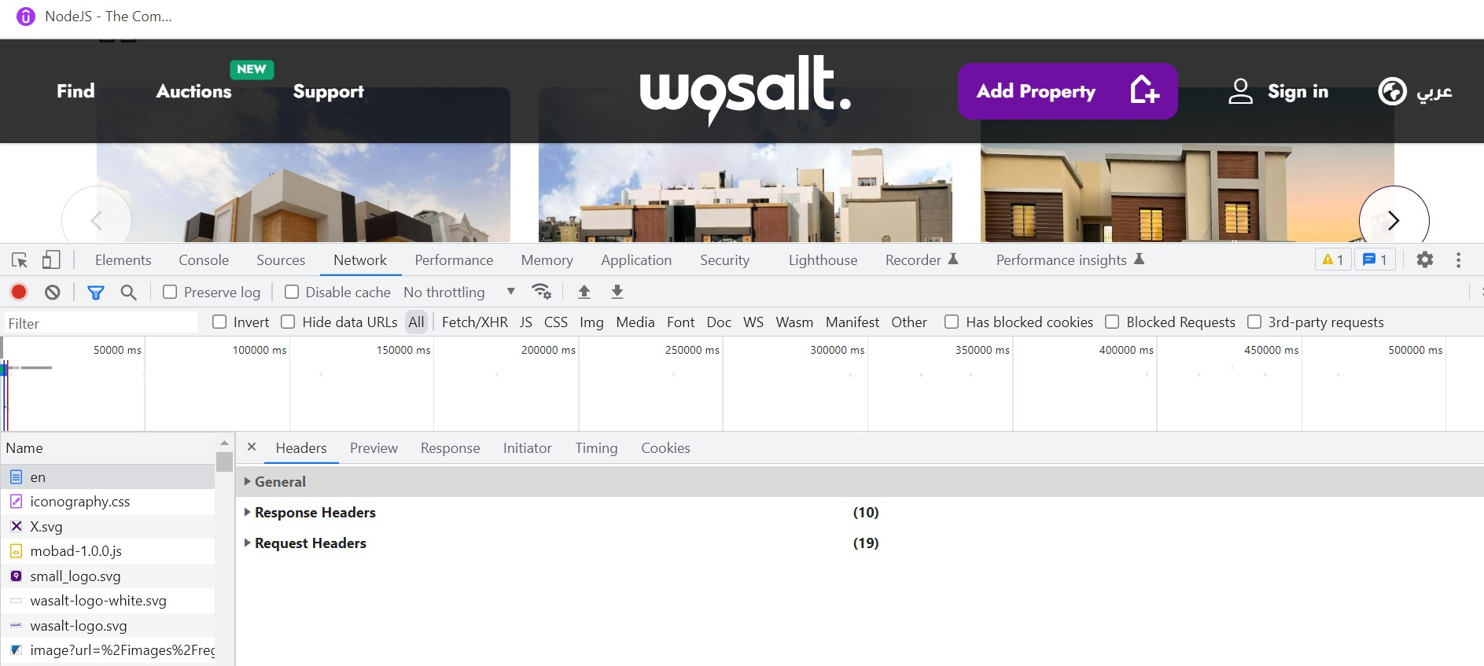

So, here basically there are three types of Http Headers

* General
* Response Headers
* Request Headers

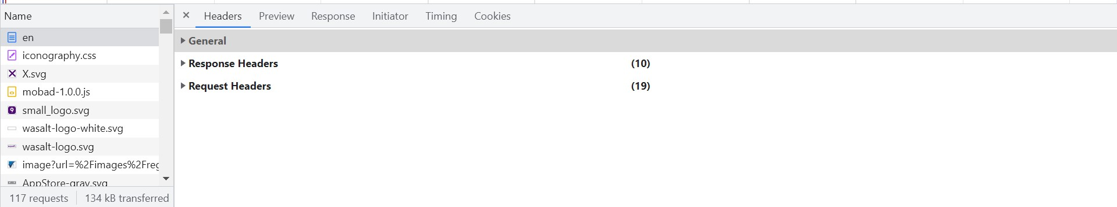

**General Headers:** This Header basically contains all the information about the Request URL, Request Method, Status Code etc. About the client.

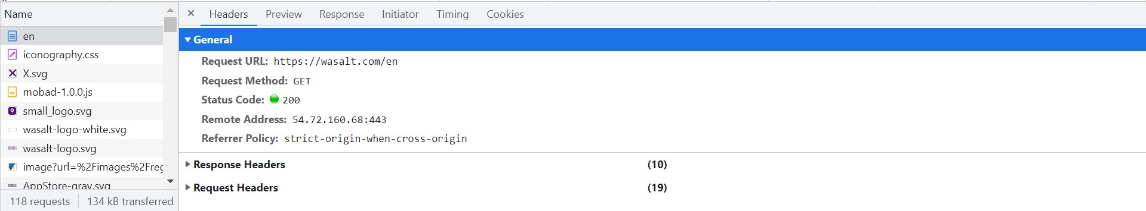

**Response Headers:** It holds additional information about the response, like its location or about the server providing it.

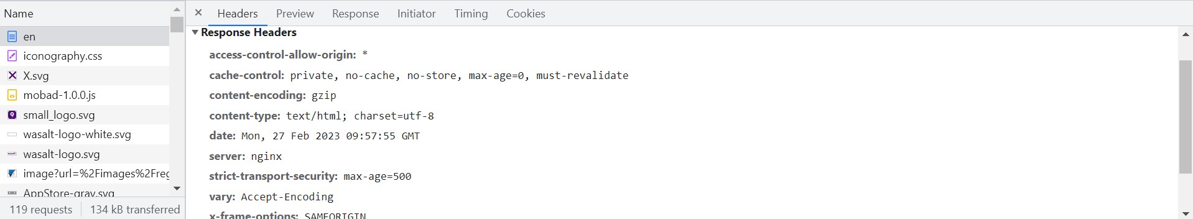

**Request Headers:** It contains more information about the resource to be fetched, or about the client requesting the resource. For example: authority name, method, path, language of the data to be accepted, Cookies. Etc.

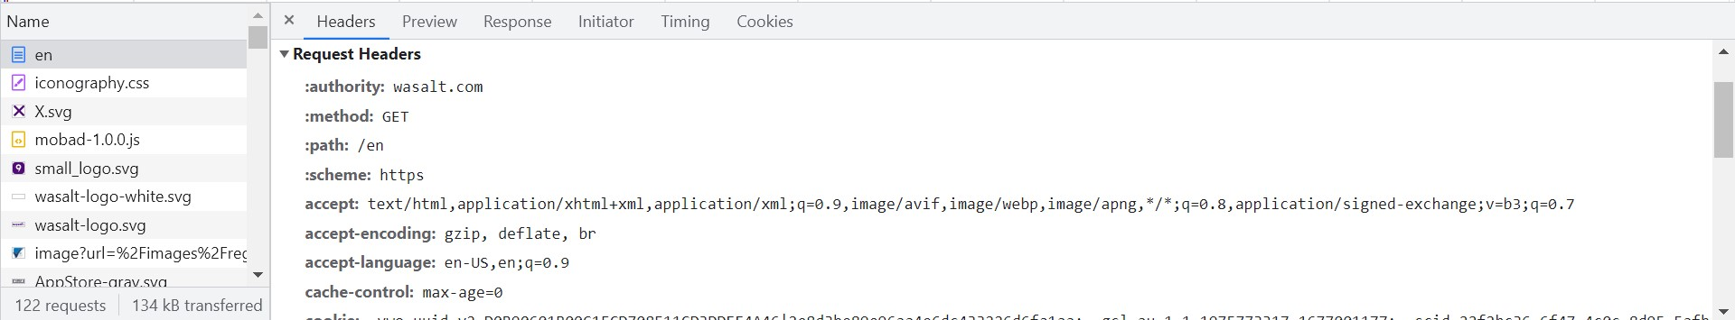

**Cookies:**

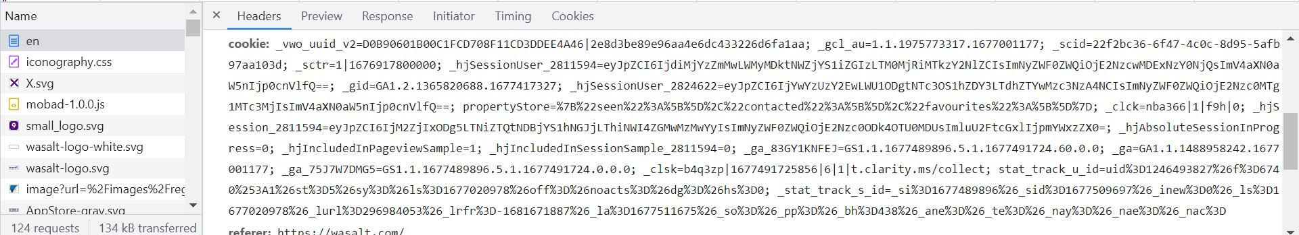

**Cookies:** Cookies are used to personalize a user's web experience with a website. It may contain the user's preferences or inputs when accessing that website. A user can customize their web browser to accept, reject, or delete cookies.

Here, these are the cookies being used in <https://wasalt.com/en> . It contains user input in value table section.

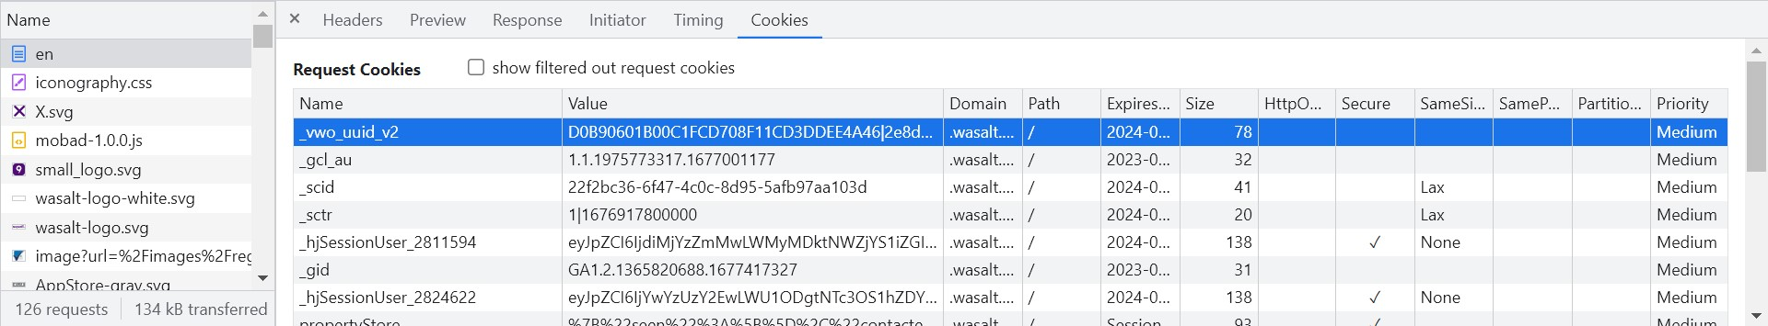

Here is the list of Cookies that have been used in the web application.

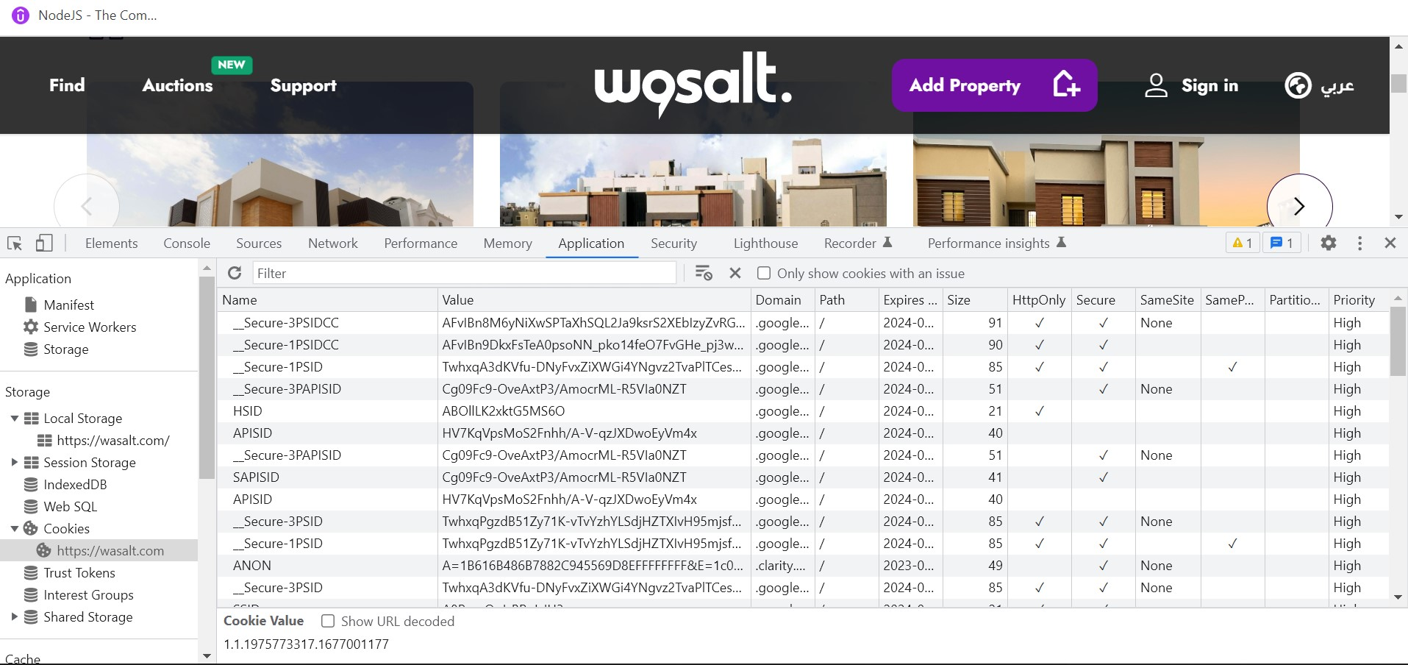

These, are the APIs that are being called with in the application.

